Event Messaging
5.2.2026

Table of contents
1 Introduction 6
1.1 Purpose 6
1.2 Scope 6
1.3 Target Audience 6
1.4 Document Structure 6
1.5 Document References 7
1.6 Glossary 7
1.7 Symbols 7
1.8 Open Issues 7
2 B2B Event channel 8
2.1 Interface overview 8
2.1.1 Collecting a micro-batch 8
2.1.2 Asynchronous Processing 9
2.1.3 Synchronous Processing 11
2.1.4 Fetching Notifications 11
2.2 Generic interface functionality 11
2.2.1 Transport level 11
2.2.1.1 Transport level Error codes 12
2.2.2 Event service operation 12
2.2.3 Event service operation implementation 13
2.2.4 Handling of duplicates 13
2.2.5 Event traceability 13
2.2.6 Guaranteed processing 14
2.2.7 HTTP version 14
2.2.8 Character set 15
2.2.9 Reporting and Dashboarding 15
2.3 Exchanging Business Events 15
2.3.1 JSON Business Event in the Payload 16
2.4 System Users 17
2.4.1 System function 18
2.4.2 Delegation 18
2.5 Timestamps 18
3 B2B Event Service operation 19
3.1 Publish operation 19
3.1.1 Request 19
3.1.2 Response 19
3.2 Token operation 19
3.2.1 Request 20
3.2.2 Response 20
3.3 Summary of error codes 21
4 Service implementations 22
4.1 Measurement Series 22
4.1.1 Validations 23
4.1.1.1 Synchronous 23
4.1.1.2 Asynchronous 23
4.1.2 Service Attributes 24
4.1.2.1 Submit Measurement value 24
4.1.2.2 Response on submitting a measurement value. 26
4.1.3 Information Model 26
4.1.3.1 Description 26
4.1.3.2 Submit Measurement values 27
4.1.3.3 Response on submit time series 30
5 Fingrid Datahub – JSON details 31
5.1 Parameters 31
5.2 Connection details 31
5.3 Recommendations 32
5.4 Fingrid Datahub Examples 33
5.4.1 GET | Token Request 33
5.4.2 GET | Token Response 33
5.4.3 POST | Publish Request 33
5.4.4 POST | Publish Response 34

Change log
Date | Version | Changes
27-02-2025 | 1.0 | First version for market review
07-01-2026 | 1.1 | Added chapter Event traceability (section 2.2.5)  Added chapter Guaranteed processing (section 2.2.6)  Added chapter Reporting and Dashboarding (section 2.2.9)  Added chapters System Function and Delegation (section 2.4.1 and 2.4.2)  Updated chapters 3.2.1, 4.1.2 and 4.1.3
05-02-2026 | 1.2 | Fixed wording (section 2.2.4, 2.2.7, 5.4)  Fixed URL and updated table (section 2.3)  Added information (section 2.4)  Updated table (section 3.2.1, 4.1.2.1, 4.1.3, 5.1, 5.3)  Updated Endpoint and query (section 5.4.1)  Updated Endpoint (section 5.4.3)  Added chapter Collecting a micro-batch (section 2.1.1)

Introduction

Purpose
This document contains the external interface specifications for the Event channel of the Fingrid Datahub. The CGI Central Market System (CMS) is used to for implementing the B2B Event channel.

Scope
The Event Channel interfaces are the external interfaces used when near real-time delivery of events is needed. Currently this channel only supports the delivery of measurement data (Metering Data Report - DH-211).
Event channel services:
- Publish operation: Interface for Market Participants to send Events to the Datahub to have them processed (asynchronously)
- Token operation: Interface for Market Participants to request a token for a specific sender/ organisation combination. Token is to be used when data is published.

Target Audience
The target audience for this document are architects, operators, development- and test teams using the Event interface of the Fingrid Datahub.

Document Structure
Information
Chapter 1 contains the general information about this document, including its purpose, short description and references to other documents.
Product Standard:
- Chapter 2 describes the generic specification for the event channel.
- Chapter 3 explains the 2 operations in more detail.
- Chapter 4 describes the specific business services which are supported by the event channel

Fingrid specific:
- Chapter 5 provides some Fingrid specific information regarding the event channel.

Document References
Reference | Document (ID) | Version | Date
DH.EXT.B2B | Datahub External Interface specification
SCHEMAS | Zip file: “ExternalnterfaceSpecification_MeasurementSeries x.x.x.zip” | 0.0.6 | 15-01-2025
DH.EVENTS | Datahub Events  Datahub tapahtumat | 2.4
DH.E.BP | Electricity retail market business processes in Datahub  Sähkön vähittäismarkkinoiden liiketoimintaprosessit datahubissa | 2.4
DH.200.VR | Validation Rules - DH-200 | 2.4

Glossary
Term | Description
CMS | CGI Central Market System / Datahub
DEQUEUE | Signoff of a retrieved Message
FIFO | First In First Out
HTTP | Hypertext Transfer Protocol
HTTPS | HyperText Transfer Protocol Secure
JSON | JavaScript Object Notation
PEEK | The retrieval of a Message from the Datahub
PKI | Public Key Infrastructure
UML | Unified Modeling Language
URL | Uniform Resource Locator
UUID | Universally unique identifier
WSDL | Web Service Description Language
XSD | XML Schema Definition Language

Symbols
The standard UML notation for flow and activity diagrams shall apply.
Text between [] refers to a document in (Document References) E.g. [DH.EXT.B2B]
Text between {} refers to implementation specific parameter in () e.g. {URL}

Open Issues
This section contains the identified open issues impacting the External Interface Specification.
# | Description | Decision | Owner

B2B Event channel
This chapter gives an overview of the B2B event channel utilized for near-real-time data publication. The Message Hub provides access to the market functions of the Datahub via web services [DH.EXT.B2B], (High performant) Rest APIs and is the gateway for Market Participants to send and receive messages. These services are executed by the use of standardized messages.
This chapter explains common functionality, patterns and mechanisms that are the same for the services which are implement with a high performant Rest API.

Interface overview
Connectivity through the Event channel is via a single Rest API using JSON representation of one transaction. This High performant REST API has two types of operations:
- POST | Publish (Publish events for Asynchronous processing).
- GET | Token (Synchronously retrieve a token with encrypted grants to use the service)
In the next paragraphs these are described in context of the different processing scenarios.

Collecting a micro-batch
Individual measurement values are aggregated into micro-batches, and these micro-batches are processed similarly as meter data messages submitted through SOAP. Micro-batches are compiled based on physical sender, juridical sender and reading timestamp in which values are reported. One micro-batch can contain multiple meter data values and multiple accounting points, but all of them must be sent by the same physical and juridical sender for the same reading timestamp. There can be multiple micro-batches being compiled at the same time, as multiple parties can report meter data to multiple reading timestamps simultaneously.
Micro-batch is complete when threshold conditions are met. Count-based threshold triggers when single batch reaches the configured count of individual measurement values. Time-based threshold triggers on a global interval, which means that all micro-batches are sent at configured time intervals, regardless of when the first measurement value of micro-batch has arrived or how many meter data values there are.

Note: If two meter data events are sent with same accounting point, same reading timestamp but different quantity or quality too close each other, events might end up in same batch. As result, both events are rejected due to “Overlapping time series detected in different transactions” error (MDM-PTV-020). Corrective meter data events must be sent only after enough time has passed since the original meter data event, so the events are processed in separate batches.

Asynchronous Processing
Publish - the event and the transaction inside the event are validated, authenticated and authorized. The Market Participant receives a technical acknowledgement via a synchronous response. When the listed checks have passed the transactions are persisted, after which functional processing of the transaction(s) is done asynchronously from the initial Publish action. Functional acknowledgements are available after functional processing through the B2B Webservice SOAP/XML PeekMessage operation [DH.EXT.B2B].
Notes:
- This event channel does not support peek and dequeue pattern. For response and forwarded messages this functionality relies on the B2B Market Messaging interfaces for peek and dequeue (see [DH.EXT.B2B] for more information).
- This channel only supports the exchange of single events and therefore does not support multiple transactions which is enforced by the OpenAPI specification of the service.
A single synchronous receipt message is sent back to indicate whether the event was accepted or rejected (such as, due to failing JSON schema validation). Asynchronously Datahub will then commence functional processing of the events where datahub currently only supports processing the received events in collections (micro-batches):
- Processed in a collection. Any subsequent functional messages (including error messages) are returned to the sending Market Participant as group as are any follow up messages sent to other Market Participants. See below figure for a visual overview of processing in a collection. As example Measurement series is used.

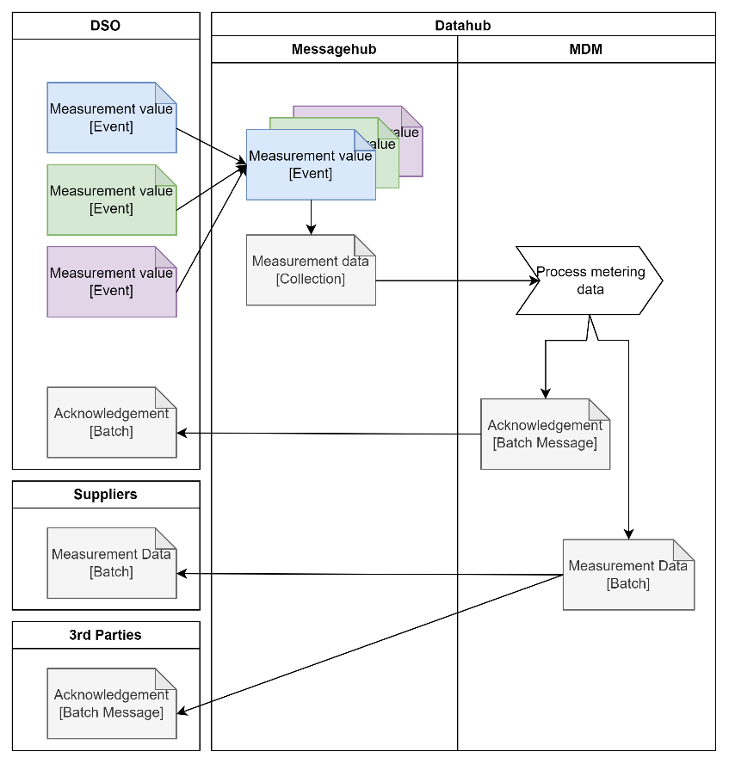
- DSO sends single measurement values as events to Datahub
- Datahub receives and checks the individual events and buffers them
- Every ‘N’ events or ‘T’ period (whatever comes first) the events are merged into a single micro batch (collection).
- MDM module processes the collection and creates an (n)acknowledgement and the forwards for other market participants of the processed collection

- Processed individually. Any subsequent functional messages (including error messages) are returned to the sending Market Participant individually as are any follow up messages sent to other Market Participants.
Currently not supported by Datahub but it is expected future event services will be added to this channel where functional processing will be done individually.

Synchronous Processing
Token – Event channel is typically used when there is a requirement for data to be published to Datahub in near-real-time. To reduce the overhead per individual event a token is required. The GET | Token allows the participant to retrieve a token which represents an authenticated user with encrypted attributes. The expiration date is configurable but typically set to an hour or so.

Fetching Notifications
The Event channel does not support fetching notifications.

Generic interface functionality
Each service operation contains functionality that is the same across the operations. This functionality is described here, so this is not replicated for every specific interface.
The generic functionality consists of:
- Transport level
- Transport level authentication.
- Event syntax validation
- Event logging of event service operation when having negative response
- Event service operation
- B2B service operation level authorization
- Audit logging of event service operation

Transport level
The authentication of System Users is handled by the Message Hub and is done differently for the two operations:
- GET | Token: The System User is authenticated by a private certificate and can only be used for B2B communication through the API’s. If the System User is not authenticated, an HTTP response with status code 401 (Access denied) is generated.
- POST | Publish: The System User is authenticated by a token which can only be used for the specific service it was requested for. If token is not present or expired the System User is not authenticated and an HTTP response with status code 401 (Access denied) is generated.

The syntax of the event is checked against its JSON schema. When the message syntax is incorrect this results in a HTTP response with status code 400. Syntax checking includes validating the event using the OpenAPI defined schema definition.

Transport level Error codes
The default HTTP codes apply in case of HTTPS transport level faults.
The following HTTP status codes are purposely returned based on the above description.
Error code | Type | Meaning
400 | System | Bad Request – Client send in a bad request, for example because of a malformed event.
401 | Security | Access Denied – User authentication based on the provided certificate has failed. (check if userIdentity is created correctly)
403 | Security | Access Denied – Client certificate is not provided or trusted. (check the certificate in the request)
404 | System | Requested resource not found
413 | System | Content length too large
500 | System | In case of any unidentified errors.

Event service operation
Typically, the events are being grouped in collections before business processing starts. The collection, without change, will be logged into the audit log and can be retrieved through the Party User Interface.
Only if all generic checks and validations succeed the request is executed.
In case of an internal technical error the HTTP code 500 will be returned. This will only be done if the error is raised before returning the synchronous response to the participant. After this it will only be logged in system log.

Event service operation implementation
The specific Event service operations are not detailed here. See the specific Event service operations in chapter 3 for more details.

Handling of duplicates
As generic principle the Event IDs provided by Market Participants in B2B messages must be unique. In case a provided Event ID is not unique the Datahub ignores the event when processing the events asynchronously.
Idempotency refers to the property of a service where performing the same request multiple times has the same effect as making it once. Idempotency is not supported by the Event Channel. Non unique event ids are always ignored.
Note: Event channel is meant for use cases where a significant number of events are expected in a short time. Duplicate check is therefore done asynchronously. Events are only temporarily stored in cache (typically 10 minutes). Only within this window duplicates can be recognized.

Event traceability
Event channel is designed to process high numbers of events per second (successfully tested to receive beyond 50.000 events per second). To allow this throughput the ingestion of events and forwarding these (as collections) to downstream modules is asynchronous.
Individual events are not stored in the business message log but the collection of events which will be forwarded to downstream modules like MDM are. Since an event translates to a transaction the transaction logging won’t be enabled for Events received through the event channel to prevent flooding the message log.

The event channel therefore relies on a mechanism called guaranteed processing which makes sure a collection of events are processed by downstream component like MDM (see 2.2.6 Guaranteed processing). This mechanism prevents the need for a market participant to know if an event was processed successful. It just needs to know if it was delivered successfully and in case of problems the sender will be notified via the acknowledgement retrieved via B2B web services which includes a reference to the original event which has been rejected. Below the mapping between attributes.

Event | ETS.SUB#TRANSACTION | ACK | Remark
tsid | TimeSeriesID | SendersSeriesIdentification | Tsid is a free field for the sender to use. It is mandatory in event channel. In case an event is functionally rejected the rejection, including this id will be provided in the ack
mrid | ExternalTransactionID | SeriesUniqueIdentification | Mrid is a unique id by the sender to be provided (e.g. with a uuid). It is mandatory in event channel. In case an event is functionally rejected the rejection, including this id will be provided in the ack

Guaranteed processing
Events received through event channel will be forwarded to downstream modules asynchronously. The event channel takes responsibility for processing the event after synchronously a confirmation has been returned to the sender that the event has been successfully received.

A retry mechanism publishes the collection of events to MDM in case an acknowledgement has not been made available in a timely fashion (configurable via environment properties) or a general exception occurred during processing resulting in the entire collection to be rejected with a general exception.

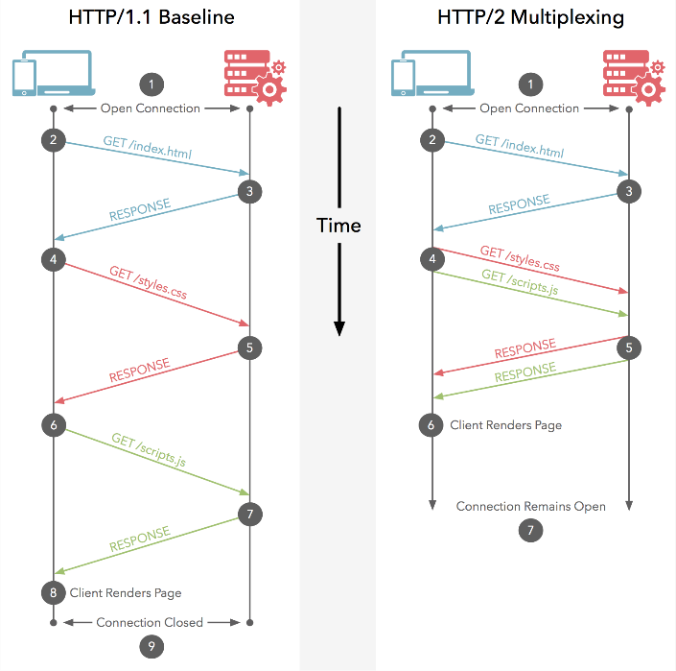
HTTP version
HTTP/2 provides support for multiplexing. By using this capability, it is possible to publish events in parallel over a single client connection.
Datahub is backwards compatible, and HTTP/1.1 can still be used but a significant lower throughput is expected because of the increased overhead with starting a lot of client connections in parallel.

Character set
Charset UTF-8 is used in all operations.

Reporting and Dashboarding
Report on Aggregated Event Log
System log is the central logging destination within CMS. The Timeseries Event Channel however can result in a lot of errors in a short timeframe (e.g. when a market participant publishes timeseries events but is not authorised to do so).
Specifically for high volume event processing as is done in Timeseries Event Channel an aggregated event log has been introduced. This log acts similar like the systemlog but will only contain errors occurred on individual timeseries events sent through the timeseries event channel.
Prior to logging, the errors will be aggregated to a 1-minute window and the type of error with a reference to the event id (mrid) of the individual event.
Report Aggregated Event Log (AEL.RPT) allows for ad-hoc reporting on this log and export is as a CSV.

Dashboard Timeseries Event Channel
A dashboard (DSH.TEC) has been introduced for the Market Operator to keep track of the health of the Timeseries Event Channel.
- An actual overview of successfully received events
- An actual overview of rejected events
- A historical overview of successfully received and rejected events (combined)
- A historical overview of unique metering points received per day

Exchanging Business Events
In the following Event service operation, the Business Messages are exchanged:
- POST | Publish: as part of the request.
- GET | Token: as part of the response.
The following URL is used for the posts:
https://<teg gateway hostname>/ec/<service>/<version>/<operation>
The following attributes are provided on the input:
A# | Name | Type | Obligation | Value | Remark
 | Connection: Client Certificate | Certificate | Conditional | The certificate provided by the client. | Only mandatory for GET | Token
 | URL: service | String | Mandatory | The service the client wants to publish events to | Event channel services are tightly coupled with functional scope. Currently only measurement-series is supported
 | URL: version | String | Mandatory | TBD | TBD
 | URL: operation | String | Mandatory | The operation the client wants to interact with | A service implemented as a high performing API has two operations Token and Publish
 | URL: <query> | String | Conditional | Query parameters for request. Only applicable for Token operation | Query parameters as described in 3.2.1
 | <Request Body> | String, UTF-8 | Conditional | The event that should be handled by the Datahub. Only applicable for Publish operation | Request body as described3.1.1.

JSON Business Event in the Payload
JSON Business Events are JSON based and are simplified where possible to reduce the overhead. This also means it only contains one transaction. OpenAPI 3.1.1 is used to specify the JSON format.

System Users
For the System User a User Identity is set up that is identified by a client certificate (PKI) for its authentication. This User Identity can be linked to one or more Organisation Users within the Datahub. The System Users can only be used for B2B communication through the B2B services including event messaging.
According to the figure 1 below, the System User (User Identity) is related to an Organisation using the Organisation User entity and System User acts on behalf of that Organisation. The same User Identity can be linked to Organisation Users for different Organisations. An Organisation can as such have multiple System Users.
A System User can only execute transactions for the specific Organisations the System User is related to.

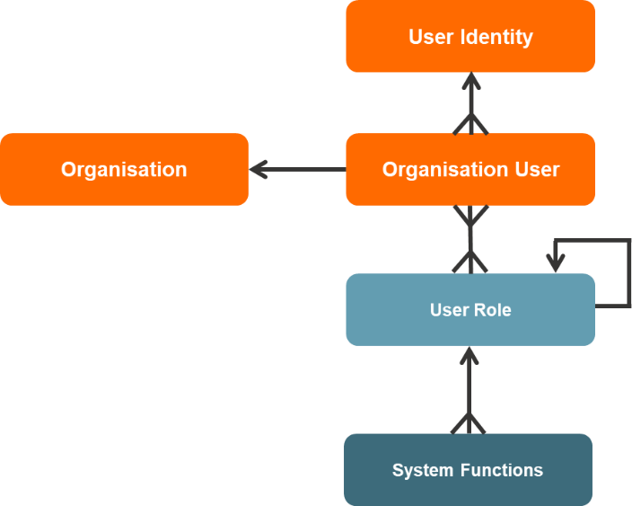
Figure 1: relation between User Identity, Organisation User, Organisation and User Roles and System Functions

Authorization of a System User is performed at 2 levels based on the User Roles attached to the linked Organisation User:
- B2B Service operation: is the System User authorized to access this B2B service operation?
- Business Messages: is the System User authorized to send in this type of Business Message on behalf of the Organisation (or the delegating Organisation)?

System function
The user requires the ETS.SUB system function to allow submitting meter data. Additionally, for using the Timeseries Event Channel, the TEC.SUB system function is required as well.

Advised configuration for the system function (Default):
- Authorisation Required: Enabled
- Audit Logging Required: Enabled’
- Required for 2.2.6 Guaranteed processing
- Message Dossier Logging Required
- Required for 2.2.5 Event traceability
- Message Transaction Logging Required: Disabled Required to prevent message dossier from being overloaded (each event is translated into a transaction)

Note: Configuration option for both ETS.SUB and TEC.SUB need to be enabled or disabled to have that corresponding result.

Delegation
In case delegation is required, the message delegation for submitting meter data (ETS.SUB) must be given to the delegated market participant by the delegating market participant. Additionally, the delegating market participant needs to provide the delegated market participant with an organisation user which has the proper rights for submitting (TEC.SUB) and processing (ETS.SUB) the timeseries data.

Note: The organisation user does not need to be a granted organisation user. But if the user is created as granted organisation user, the grantee needs to be the delegated organisation.

Timestamps
Datahub logs the timestamp for each incoming operation request and each outgoing operation response. These timestamps are logged in the system and used for reporting. Any timestamps in the message and transactions as provided by the Market Participant are stored for reference but not used for operational management or reporting. All timestamps in B2B communication are presented in UTC and in XML format YYYY-MM-DDTHH:MM:SS+00:00 or YYYY-MM-DDTHH:MM:SSZ. All timestamps that are stored in the system are stored in UTC.

B2B Event Service operation
This chapter describes the external interfaces used in a B2B Event context.

Publish operation
A System User uses ‘Publish’ to send JSON Business Events concerning a market process to the Datahub. The operation implementation does not directly execute the Market processes but only receives, checks the syntax, authorization and forwards the Business Event internally. Therefore, the response is only a technical acknowledgement to indicate that the event is received and will be processed. The actual processing of the Business Events is done internally (i.e. asynchronously).

Request
Attribute |  | Obligation | Type | Notes
Authorization |  | Mandatory | Header Attribute | Bearer token retrieved from GET | Token (3.2 Token operation)
 | Payload | Mandatory | String | Contains the actual Business Event in JSON message format.  Payload should comply with the event definition

The following rules are enforced:
- The Payload is syntactically correct (validated against the schema definition)
- The System User is authorized to send in the message (Document Type) for the Sender mentioned in the Business Message.
Failing these rules will result in a corresponding HTTP Fault.

Response
HTTP status code and in case of a rejection a HTTP reason.

Token operation
A System User uses the Token operation to retrieve a token from the Datahub. If the System User is successfully authenticated, the Datahub will respond with a token including encrypted attributes. The token is to be used by the market participant in the Publish operation and needs to be refreshed timely.

Request
Element | Obligation | Type | Notes
senderorganisation | Conditional | Query | Required when events are sent on behalf of a delegating organisation.  The organisation belonging to the provided OrganisationUser is the delegating organisation where sender organisation is the delegated organisation
organisationuser | Mandatory | Query | The Username is used to uniquely identify the OrganisationUser to be used to do the requests.  This allows linking multiple OrganisationUsers to one UserIdentity.  In case of delegation, the organisationuser belongs to the juridical organisation which is the delegating organisation.
tenantcode | Mandatory | Query | The Tenant the organisation belongs to.

Response
Element | Obligation | Type | Notes
Token | 1..1 | JSON | e.g.  {  "token": "oweflkadfjklqefaeflkaslnk "  }

Summary of error codes
This section provides a summary of all error codes that may occur.
Transport level error codes
Error code | Type | Meaning
400 | System | Bad Request
401 | Security | Access Denied –. User authentication based on the provided certificate has failed. (check if userIdentity is created correctly)
403 | Security | Access Denied – Client certificate is not provided or trusted. (check the certificate in the request)
404 | System | Requested resource not found
413 | System | Content length too large
500 | System | In case of any unidentified errors.

Service implementations
This section describes the specific services implemented with the Event channel.
Currently the event channel supports the following services:
- Measurement Series

Measurement Series
This chapter described the service Measurement Series which is introduced as an alternative for the existing E66 interface and the new type of interface (High performance Event Channel) which enables this service to comply to the high-performance demands.
The service allows a Market Participant in the role of Metered Data Responsible to execute the Business Process “Metering Data Report (DH-211)” by providing individual measurement values as events.
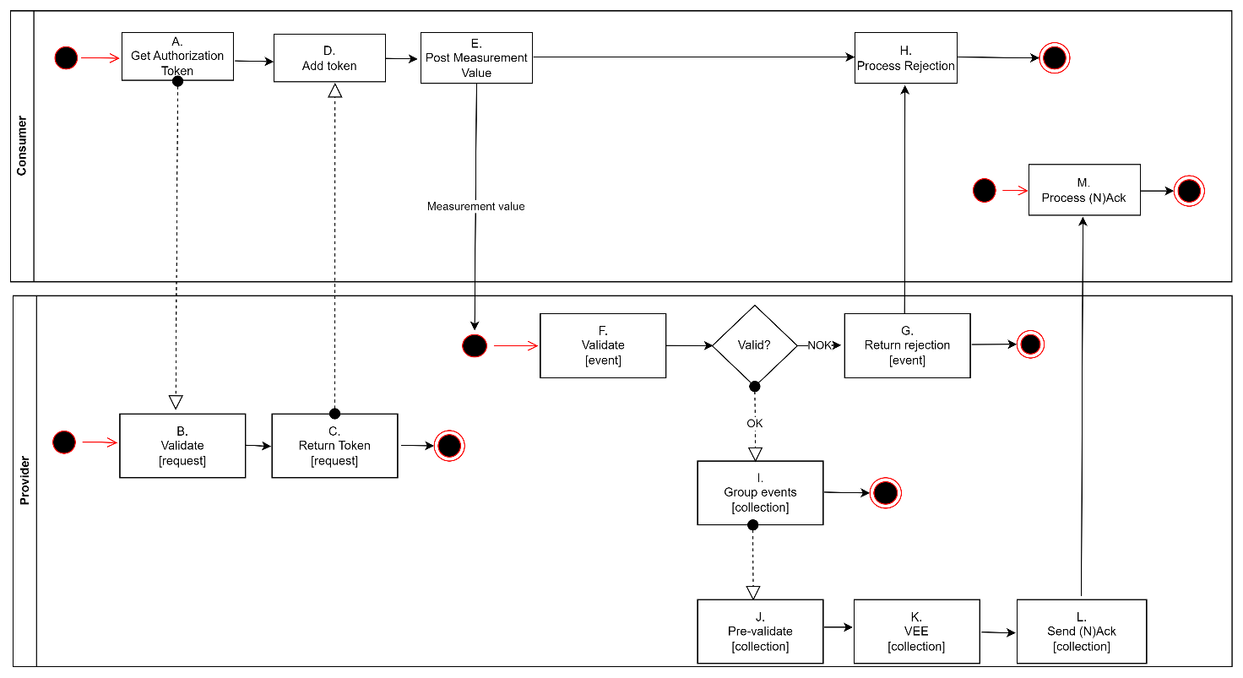
The process for submitting the individual measurement values follows the following steps:
- The consumer of the service requests [A] an authorization token via GET GetAuthorizationToken
- The provider of the Authorization Service verifies [B] if the consumer is authenticated and authorized for the requested service. The request is immediately rejected when provider determines the consumer is not allowed to access the requested service and no token will be provided. If consumer is allowed to call the requested service a token (including encrypted grants) will be returned [C].
- The consumer of the service sends [E] a measurement value via POST Measurement Series with a valid token added to the request [D].
- The provider of the service verifies [F] the validity of the token and verifies if the consumer corresponds with the sender in the event. The event is syntactically validated against its JSON schema. The event is immediately rejected [G] when errors have been found, and the consumer is expected to correct [H] the event before resending it.
- If the respective consumer is authenticated and authorized for this service and all other synchronous validations were successful, a synchronous confirmation (http status 200) will be returned to the consumer.
- The provider will synchronously buffer the events before they are asynchronously grouped in collections[I] for further processing. Any duplicates, determined by the event id (mrid) will be excluded and logged for analysis. The collection of events will be checked [J+K]] for functional content, as described in the section 4.1.1 Validations and functionally processed as described in [DH.E.BP].
- If the event is processed successfully, a functional acknowledgement [L] is returned to the sender, the distribution rules will be applied. The functional acknowledgements and the distributions to retailers will be bundled according to the collection internally made at step 6.
- If the event is functionally rejected, the provider sends a rejection to the consumer [L]. The rejections will be bundled according to the collection internally made at step 6.

Validations
In response to the message "Submit Measurement value" the provider has the following checks and notifications at their disposal and performs these checks:

Synchronous
Validation | Error description | Error codes | HTTP status | HTTP code
The consumer is authenticated for the service |  |  | Unauthorized | 401
The consumer is authorized for the service |  |  | Forbidden | 403
The event is syntactically valid |  |  | Bad Request | 400

Asynchronous
Business rules are defined in [DH.E.BP], [DH.EVENTS] and [DH.200.VR]

Service Attributes

Submit Measurement value
For a notification with measurement series the following functional parameters are relevant:
Attribute | Elec |  | 1/n |  | Remark | Enumeration
Unique Event identification | M |  | 1 |  | A UUID as a unique identifier for the message
Metering timeseries identification | O |  | 1 |  | An external identifier which is not stored by the Datahub but will be returned in rejections
Metering point identification | M |  | 1 |  | The identifying code (GSRN ) of the connection.
Technical sender of event (sender of the timeseries) | M |  | 1 |  | GLN compliant ID of the party providing the timeseries
Juridical sender of event (owner of the timeseries) | M |  | 1 |  | The GLN compliant ID of the metering data responsible party who is owner of the data
Metering grid area identification | C |  | 1 |  | The identifying code of the grid area.  To be used for production and consumption metering points (not for exchange points)
Metering grid area identification (infeed) | C |  | 1 |  | The identifying code of the infeed grid area  To be used for exchange points
Metering grid area identification (outfeed) | C |  | 1 |  | The identifying code of the outfeed grid area  To be used for exchange points
Industry type | M |  | 1 |  | Allowed values (from the ebIX Code list [6]):  Electricity | 23
Date/time of event creation | M |  | 1 |  | The date/time when the event was drafted, in UTC and conforming to the ISO 8601 notation [7]: YYYY-MM-DDThh:mm:ssZ.
Metering point type | M |  | 1 |  | The metering point type:  Exchange point  Accounting point  Production Unit | E20  F01  E18
Channel |  |  | 1..1
Time step | M |  | 1 |  | Resolution conforms to the ISO 8601 notation for Duration.  Allowed values for electricity:  15 minutes  1 hour | PT15M  PT1H
Metering time series type | M |  | 1 |  | Allowed values (from ebIX Code list):  For electricity:  Active energy  Reactive energy (Connection points)  Reactive energy input  Reactive energy output | 8716867000030  8716867000047  8716867000139  8716867000146
Unit | M |  | 1 |  | Allowed value for active energy.  Wh  kWh  MWh  Allowed value for reactive energy:  varh  Kvarh  Mvarh | Wh  kWh  MWh  varh  kvarh  Mvarh
Volume |  | 1
Start time | M |  | 1 |  | The start date/time of the observation period of the event, in UTC and conforming to the ISO 8601 notation [7]: YYYY-MM-DDThh:mm:ssZ.
Value | M |  | 1 |  | Volume containing a maximum of 8 integers and 6 decimal numbers.  e.g 17347492.123000
Status | O |  | 1 |  | Quality of the volume. Default is metered  Uncertain  Estimated  Corrected OK  Temporary  Estimated, approved for billing | Z02  99  Z01  21  56
Mandatory fields (M) are always filled; optional fields (O) or Conditional fields (C) if required for the context of the respective message.

Response on submitting a measurement value.
The synchronous response to the measurement series notification is either an approval or a rejection:
Confirmation:
HTTP status description | HTTP status code
OK | 200

Rejection:
HTTP status description | HTTP status code
Unauthorized | 401
Forbidden | 403
Bad Request | 400

Information Model

Description
The information model is displayed as a class diagram. Each class diagram is followed by a table describing the elements, except for the class diagrams of "empty" messages that are exchanged for confirmation.
Multiplicity is indicated next to the elements. The notation 0..1 means optionally once, 1..1 means the element occurs once (mandatory). The notation 0..* means the element may occur multiple times optionally. The notation 1..* means the element occurs one or more times (mandatory).

Submit Measurement values
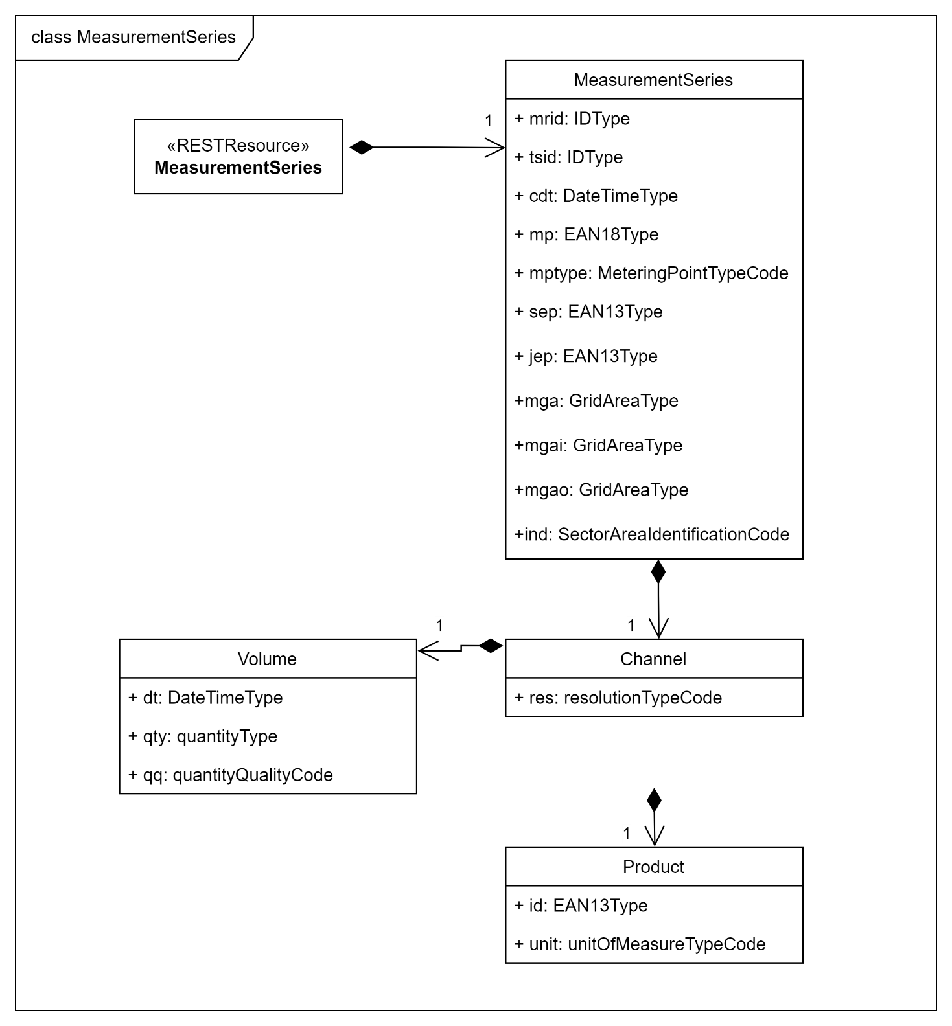

Channel (ch) [1..1]
JSON element | Datatype | Multiplicity | Restrictions | Description | Functional Attribute
res  (resolution) | resolutionTypeCode | 1..1 | String  Enum:  [PT15M, PT1H] | The definition of the number of units of time that compose an individual step within a period.  Example: PT15M | Measurement Resolution

MeasurementSeries [1..1]
JSON element | Datatype | Multiplicity | Restrictions | Description | Functional Attribute
mrid | IDType | 1..1 | String:  minLength: 1  maxLength: 50 | A unique identification of the time series event.  Example:  e3d5ced9-3b0a-4e46-ba55-4cad6cdf2e56 | Unique Event identification
tsid | IDType | 0..1 | String:  minLength: 1  maxLength: 255 | An external identification of the timeseries event. Not persisted in Datahub but returned in asynchronous rejections.  Example:  e3d5ced9-3b0a-4e46-ba55-4cad6cdf2e56 | Metering timeseries identification
ind  (industry) | SectorAreaIdentificationCode | 1..1 | String  Enum:  [23] | The identification of the energy product (electricity, gas etc.), from ebIX Code  Example: 23 | Industry type
cdt  (creationDateTime) | DateTimeType | 1..1 | String  Pattern: date-time | Date/time of the creation of the time series as per ISO 8601 YYYY-MM-DDThh:mm:ssZ.  Example: 2024-04-03T08:21:56Z | Date/time of event creation
mp  (Metering Point) | EAN18Type | 1..1 | String  minLength: 1  maxLength: 25 | The unique identification of the market evaluation point.  Example: 640502010245201095 | Metering point identification
mptype  (Metering Point Type | MeteringPointTypeCode | 1..1 | String  Enum:  [F01, E18, E20] | The identification of the metering point type, from ebIX Code  Example: F01, E18, E20 | Metering point Type
sep  (Sending Energy Party) | EAN13Type | 1..1 | String  minLength: 1  maxLength: 64 | The identification of a party in the energy market.  Example: 8716892000005 | Technical sender of event
jep  (Juridical Energy Party | EAN13Type | 1..1 | String  minLength: 1  maxLength: 64 | The identification of a party in the energy market.  Example: 8716892000005 | Juridical sender of event
mga | GridAreaType | 0..1 | String  minLength: 1  maxLength: 25 | The unique identification of the grid area.  Example: 0000562140649364 | Metering grid area identification
mgai | GridAreaType | 0..1 | String  minLength: 1  maxLength: 25 | The unique identification of the grid area.  Example: 0000562140649364 | Metering grid area identification (infeed)
mgao | GridAreaType | 0..1 | String  minLength: 1  maxLength: 25 | The unique identification of the grid area.  Example: 0000562140649364 | Metering grid area identification (outfeed)

Volume (vol) [1..1]
JSON element | Datatype | Multiplicity | Restrictions | Description | Functional Attribute
dt  (date time) | DateTimeType | 1..1 | String  Pattern: date-time | Start date/time of the measurement of the time series as per ISO 8601 YYYY-MM-DDThh:mm:ssZ.  Example: 2024-07-01T00:00:00Z | Start time
qty  (quantity) | quantityType | 1..1 | Number  8,6 | The validated quantity of energy for this observation.  Example for volume: 11113221.323423 | Value
qq  (quantity quality) | quantityQualityCode | 1..1 | String  Enum:  [Z02, 99, Z01, 21, 56] | Quality of the measurement  Example: 99 | Status

Product [1..1]
JSON element | Datatype | Multiplicity | Restrictions | Description | Functional Attribute
id  (identification) | EAN13Type | 1..1 | String  Enum:  [ 8716867000030, 8716867000139, 8716867000146, 8716867000047 ] | The unique identification (EAN13) of the product.  Example: 8716867000030 | Metering time series type
unit  (measureUnit) | unitOfMeasureTypeCode | 1..1 | String  Enum:  [kWh, kvarh, Wh, MWh, GWh, varh, Mvarh, Gvarh] | The identification of the measure unit.  Example: kWh | Unit

Response on submit time series
The response to the submitted dataset of measurement values is an HTTP status code, as detailed in section 4.1.1.1 Synchronous

Fingrid Datahub – JSON details
This section contains Fingrid specific recommendations, file descriptions and examples.
The OpenAPI specification is shared via [SCHEMAS].

Parameters
Parameters for Fingrid
Parameter | Value
{tenantcode} | FGR
{URL} | Will be communicated separately.
{organisationuser} | Specific per Organisation. Defines the registered b2b user in the Datahub created by Fingrid having specific UserRoles for B2B communication.

Connection details
Parameter | Value
Protocol | HTTPS (TLS 1.3)
Port | 443
HTTP Version | 2 (backwards compatible)
Style / use | Document / Literal

Recommendations
Recommendations for the use of the B2B-Event interface.
A system not operating according to these recommendations is considered to be using the interface incorrectly.
# | Recommendations | Reasoning
 | UTF-8 shall be used for the JSON events.  Content-Type: application/json; charset=UTF-8 | Preventing encoding issues.
 | Prevent pretty print. | Pretty printing gives overhead of quite some whitespace.
 | Use of UUID in message ID | Ensuring uniqueness of identifiers.
 | Prevent sending events for same accounting point/period with different channels | Datahub does support processing messages in both the event and b2b channel but cannot guarantee a sequence in processing when messages are sent in parallel.
 | Timely request a new token | It is possible to refresh a token at any time, even when the previous one is not expired. Make sure no events are published with an expired token since this will result in a significant amount of rejected events.

Fingrid Datahub Examples
The examples are for showing correct structure of the events. The values used for elements do apply the schema validation rules but are not based on real data.

GET | Token Request
Endpoint: ../ec/measurement-series/v1/token
Query: ?tenantcode=FGR&organisationuser=FictiveUser&senderorganisation=FictiveParty
Note: Request does not contain a payload

GET | Token Response
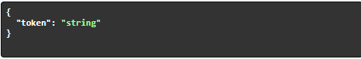

In case of a rejection (e.g. 400 – Bad Request):
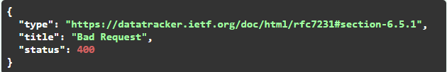

POST | Publish Request
Endpoint: ../ec/measurement-series/v1/publish
Content-Type: application/json
Authorization: Bearer {token}

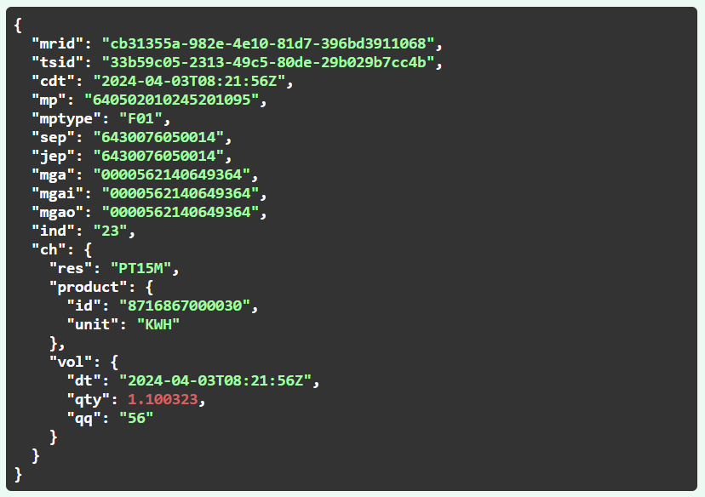

POST | Publish Response
If the event has been successfully received Datahub will respond with HTTP status code 202

In case of a rejection (e.g. 400 – Bad Request):

https://spec.openapis.org/oas/latest.html
Datahub as receiver of the measurement data.
Is the DSO as the producer of the measurement data
https://www.gs1.org/standards/id-keys/gsrn
https://www.gs1.org/standards/id-keys/gln
Statuscode/status description ‘200 OK’ means the datahub has successfully received the event and will continue with processing the event in MDM.

